SIMATS ENGINEERING
ASSESSMENT TOOL 3: Coding Challenge

COURSE NAME: Embedded Systems
COURSE CODE: ECA1421

COURSE OUTCOME COVERED

CO2: Apply Embedded C programming concepts, including structured design, real-time constraint handling, and SystemC-based modeling, to develop and analyze embedded applications for industrial use cases. (BL5)

Name of the Student : Parameswari K
Register Number : 192372266

Type Your Question Here:
1.Design an Embedded C firmware for fault detection using threshold logic in industrial
systems.
2. Construct a program comparing polling-based delay and interrupt-based timing in
Embedded C.

Q.No | Problem Understanding (10) | Algorithm (12.5) | Code Implementation (10) | Competitive Performance (10) | Output Validation (7.5) | Total(50)
1
2

Code of Conduct:

I Parameswari K 192372266(Name / Reg No) certify that this submission is my original work and that I have adhered to the guidelines specified for this assessment.
I understand that any violation of academic integrity rules will result in disciplinary action.

Signature of the student:
Aim

To design and implement an Embedded C firmware for an industrial fault detection system that continuously monitors sensor values and generates an alert whenever the measured value exceeds a predefined threshold.

Hardware
- AT89C51 Microcontroller
- Temperature/Pressure Sensor
- LED
- Buzzer
- Power Supply (5V)

Software
- Embedded C
- Keil µVision
- Proteus 8 Professional

Algorithm
- Start.
- Initialize the microcontroller and output devices (LED and Buzzer).
- Read the sensor value.
- Compare the sensor value with the threshold.
- If the sensor value is greater than the threshold:
- Turn ON the LED.
- Turn ON the Buzzer.
- Otherwise:
  - Turn OFF the LED.
  - Turn OFF the Buzzer.
- Repeat the process continuously.
- Stop.

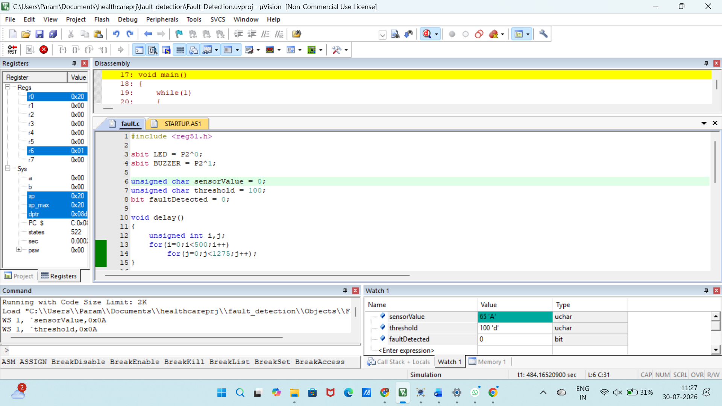
Figure 1 Keil simulation for Fraud detection

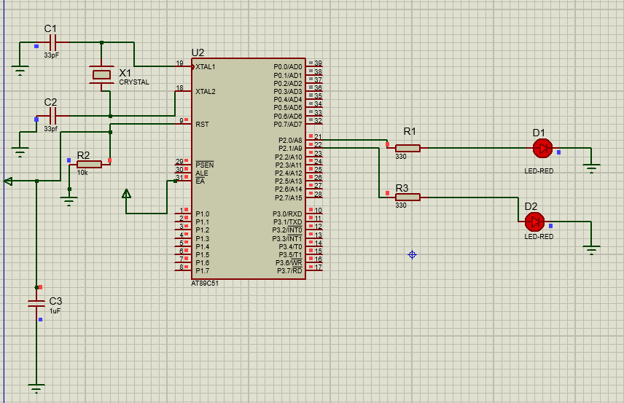
Figure 2 Schematic Representation of Fraud detection in Proteus

Result
The firmware continuously compares the sensor value with the predefined threshold. If the sensor value exceeds the threshold, both LEDs turn ON to indicate a fault condition. When the sensor value is below the threshold, both LEDs remain OFF, indicating normal operation.

Construct a program comparing polling-based delay and interrupt-based timing in Embedded C.

Aim
To compare polling-based delay and interrupt-based timing in Embedded C using the AT89C51 microcontroller.

Design Requirements
Hardware
- AT89C51 Microcontroller
- LED
- Crystal Oscillator
- Push Button (Optional)
- Power Supply (5V)
Software
- Keil µVision
- Proteus 8 Professional
- Embedded C

Algorithm - Polling-Based Delay
- Start the program.
- Initialize Port P2.0 as the LED output.
- Configure Timer0 in Mode 1 (16-bit timer).
- Load the initial values into TH0 and TL0 registers.
- Start Timer0 by setting the TR0 bit.
- Continuously check (poll) the TF0 (Timer Overflow Flag).
- If TF0 = 0, continue polling until the timer overflows.
- When TF0 = 1, stop Timer0.
- Clear the TF0 flag.
- Toggle the LED connected to P2.0.
- Reload the timer values.
- Repeat Steps 5–11 continuously to generate periodic LED blinking.
- Stop.

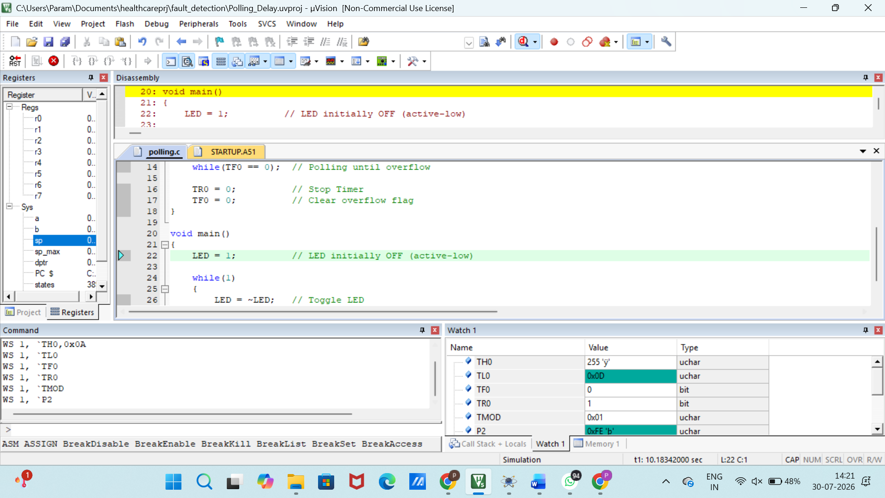
Figure 3 Keil simulation for Polling-Based Delay
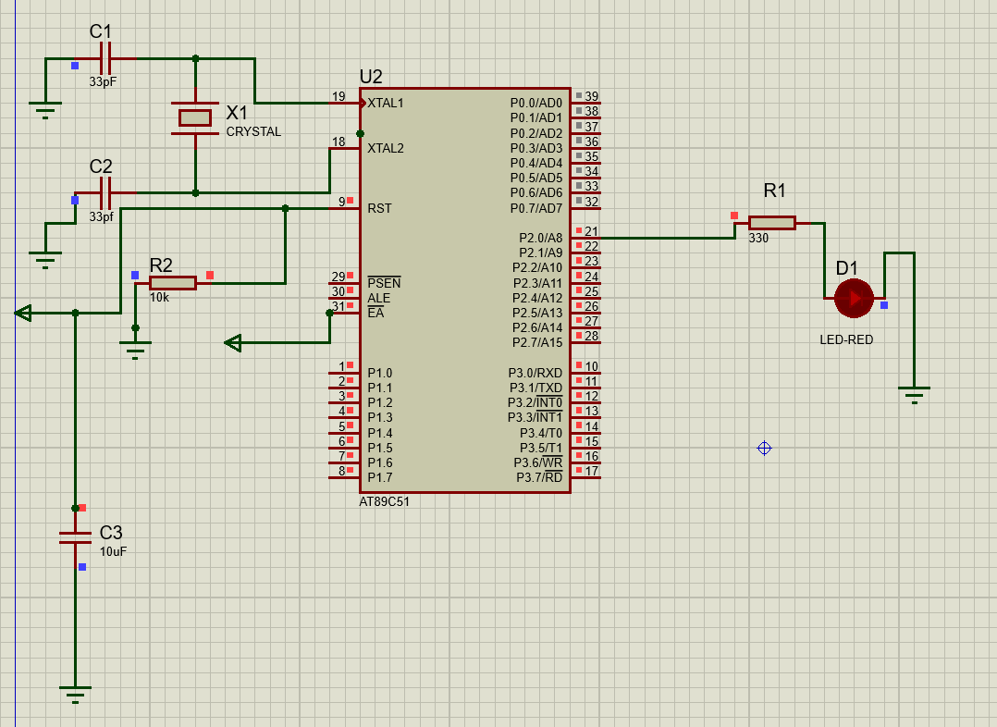
Figure 4 Schematic Representation of Polling-Based Delay in Proteus

Observation (Polling-Based Delay)
The polling-based delay program was executed successfully in Proteus. The LED connected to Port P2.0 blinked periodically as the CPU continuously monitored the Timer0 overflow flag (TF0). This verified the successful operation of the polling-based timing method.

Algorithm – Interrupt-Based Timing
- Start the program.
- Initialize Port P2.0 as the LED output.
- Configure Timer0 in Mode 1 (16-bit timer).
- Load the initial values into TH0 and TL0 registers.
- Enable Timer0 Interrupt (ET0 = 1).
- Enable Global Interrupt (EA = 1).
- Start Timer0 by setting the TR0 bit.
- Execute the main program continuously.
- When Timer0 overflows, an interrupt request is generated automatically.
- The CPU temporarily suspends the main program and enters the Timer0 Interrupt Service Routine (ISR).
- Inside the ISR:
  - Reload TH0 and TL0.
  - Toggle the LED connected to P2.0.
- Return from the ISR and continue executing the main program.
- Repeat Steps 8–12 continuously.
- Stop.

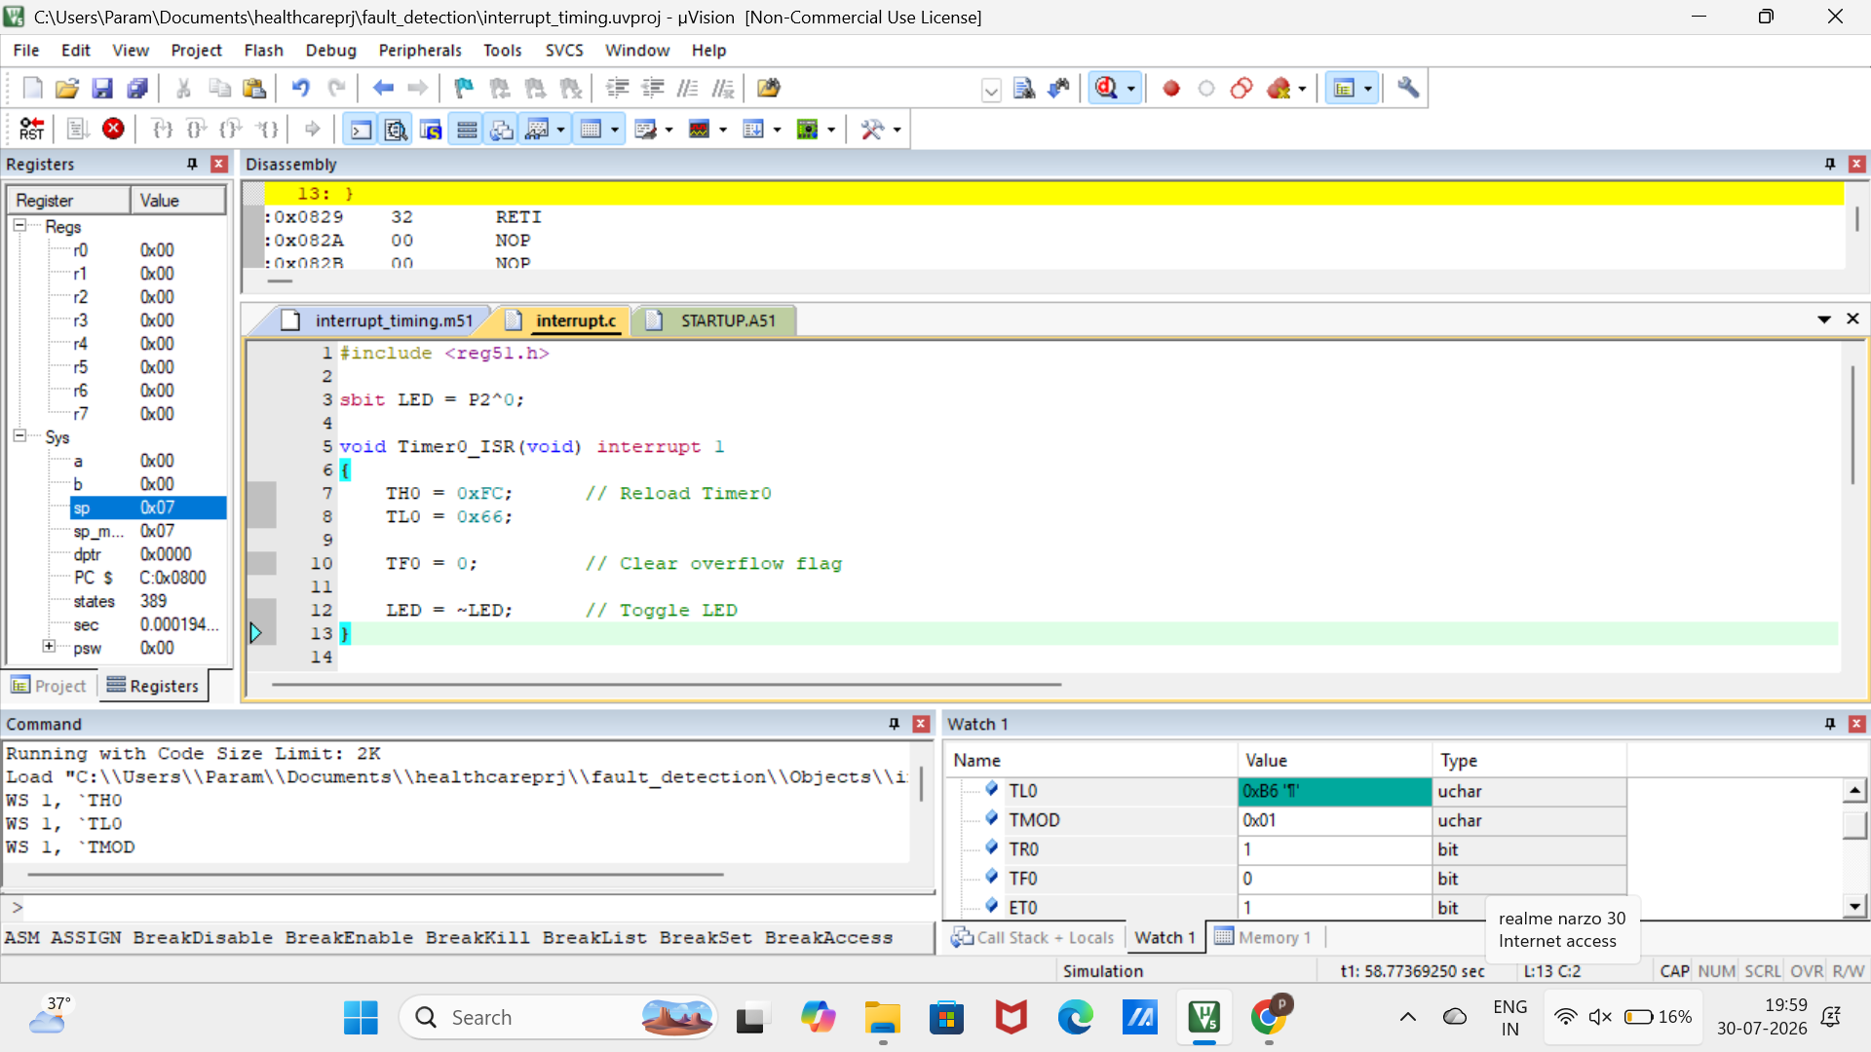
Figure 6 Keil simulation for Interrupt-Based Timing


Figure 7 Schematic Representation of Interrupt-Based Timing in Proteus

Observation (Interrupt-Based Timing)
The interrupt-based timing program was executed successfully in Proteus. The LED connected to Port P2.0 blinked periodically through Timer0 interrupts. The Timer0 Interrupt Service Routine (ISR) automatically toggled the LED, demonstrating efficient interrupt-driven timing.

Result
The polling-based delay and interrupt-based timing programs were executed successfully. The comparison showed that the interrupt method provides better CPU utilization by responding to timer events automatically, whereas the polling method continuously checks the timer status.

Github Link :
https://github.com/paramzzz/ECA1421-EMBEDDED-SYSTEM.git

